**Summary of further training on Deeplab**

* **Training on Deeplab model**

**Goal**: Training deeplab to get more precise segmentation

**Dataset**: 32000 synthetic images provided by Bowing

**Method**: Adjusted the source code of Deeplab from Tensorflow library. Organized the custom data structure as

required. (Relative modification in source code see here)

**Training:** -6000 epochs

**Test Data:** some result on test data (test data is field data captured from real world)

* **Phase 1:**

Training result for more than 8000 synthetic images in group 1:

* Overall, Further training Deeplab on custom dataset did improve the segmentation quality, especially on some detail level.

Original images pretrained model fine-tuned model

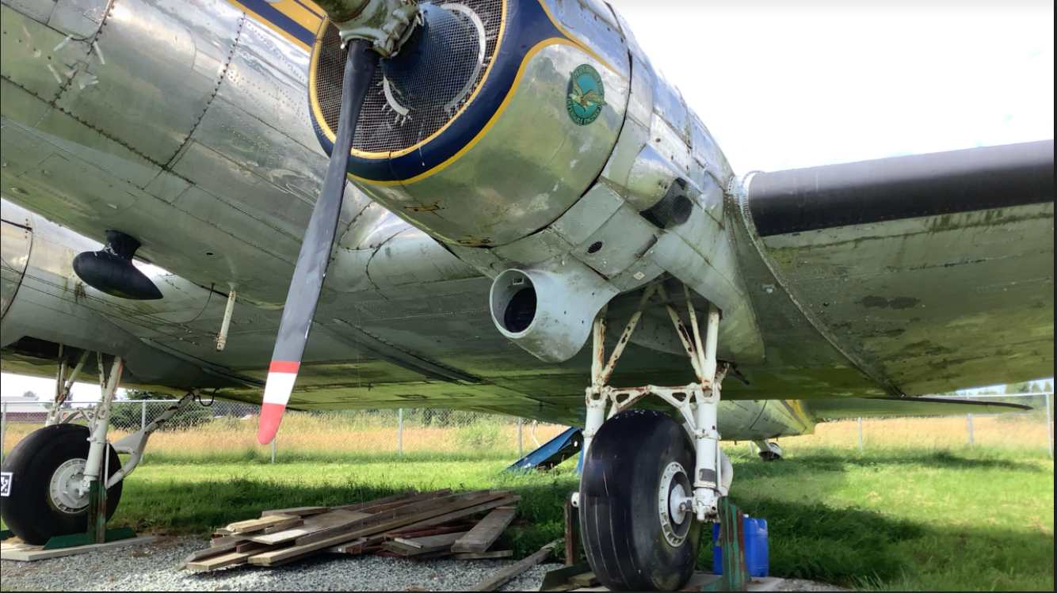 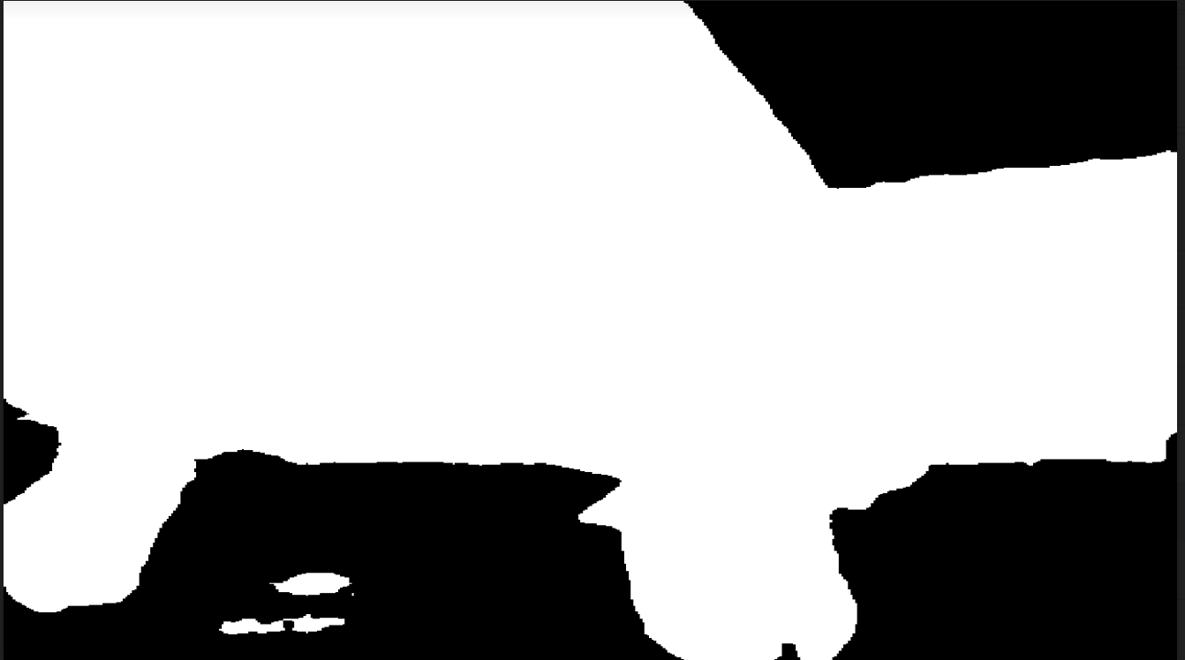 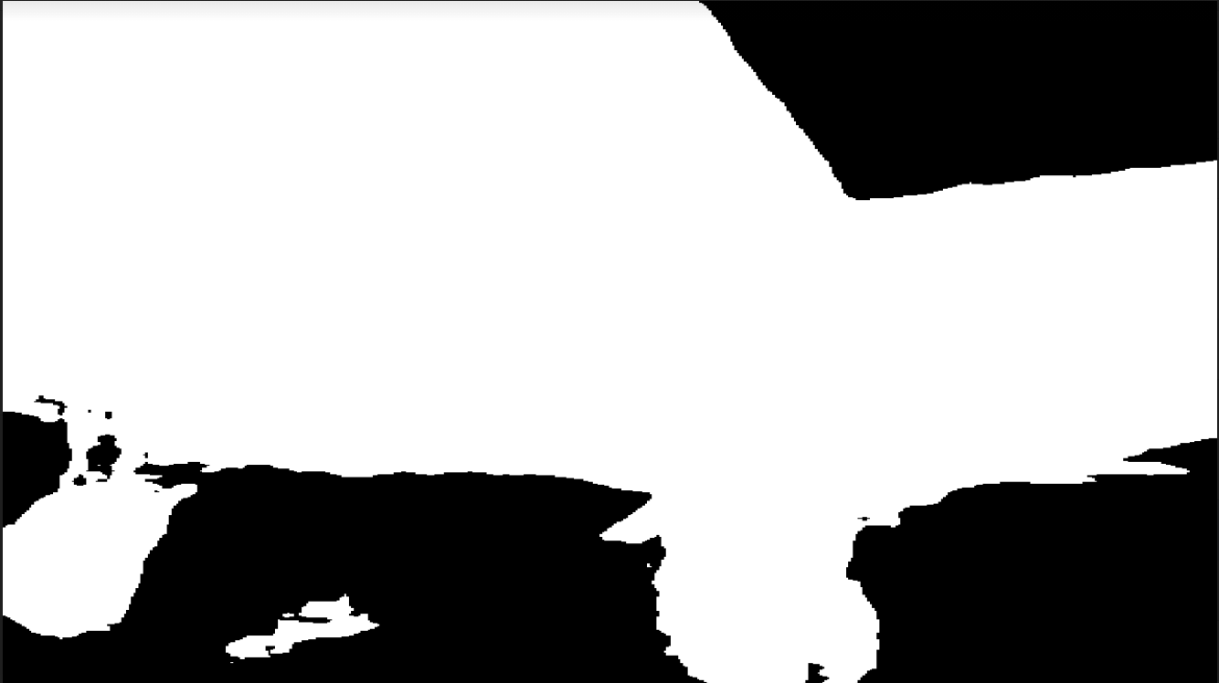

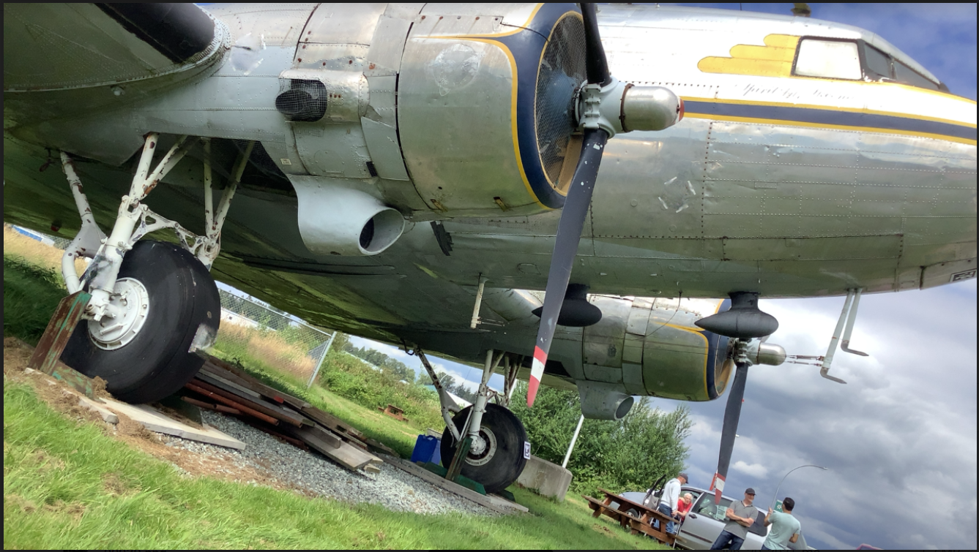 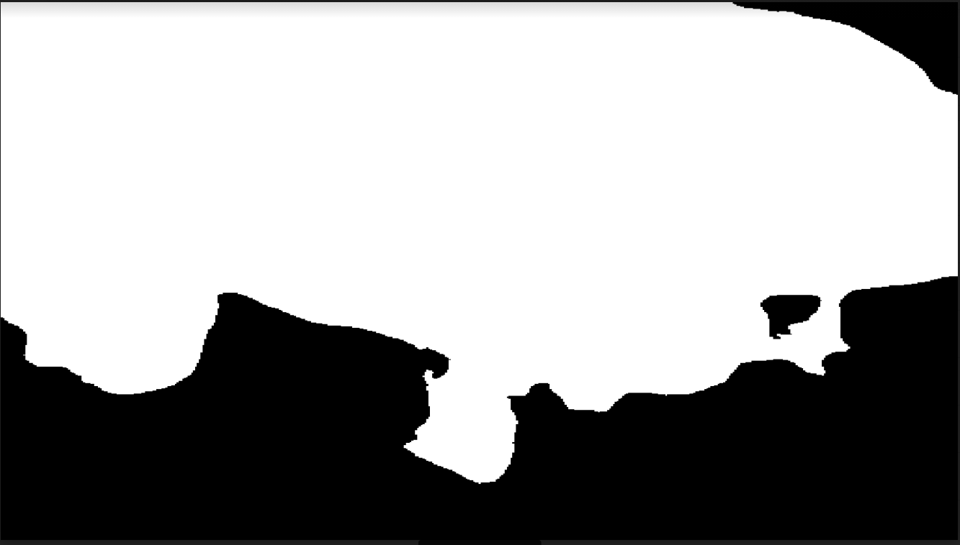 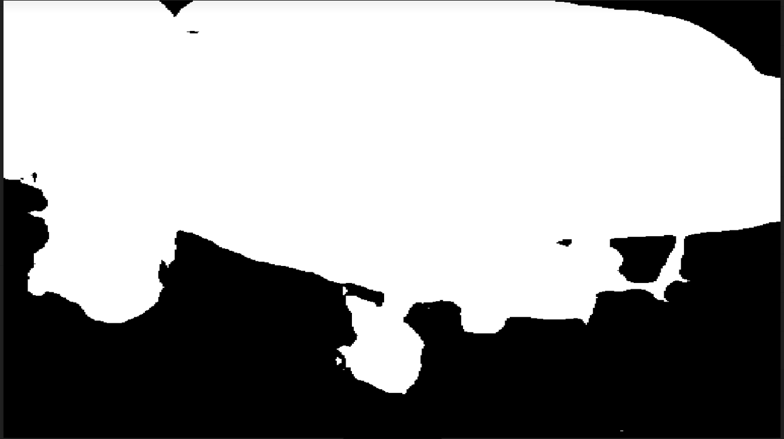

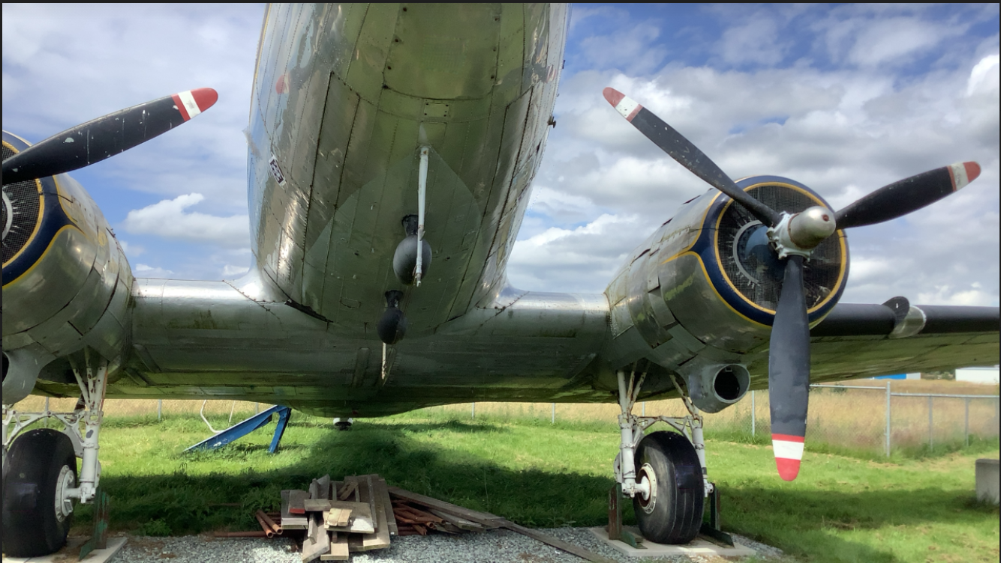 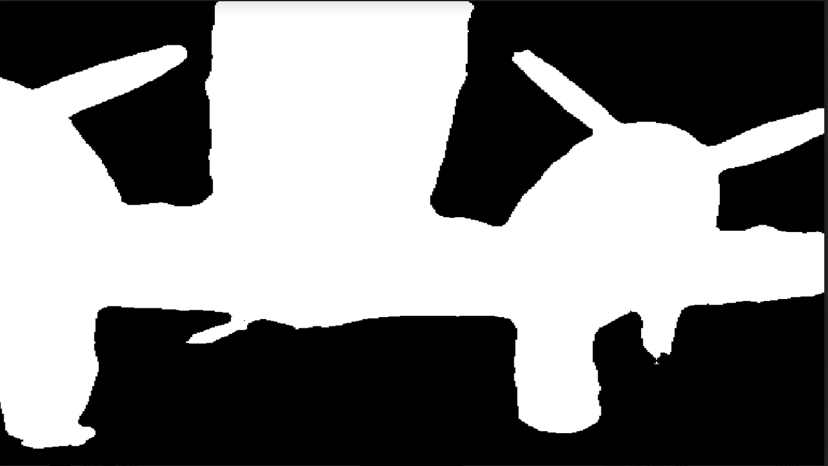 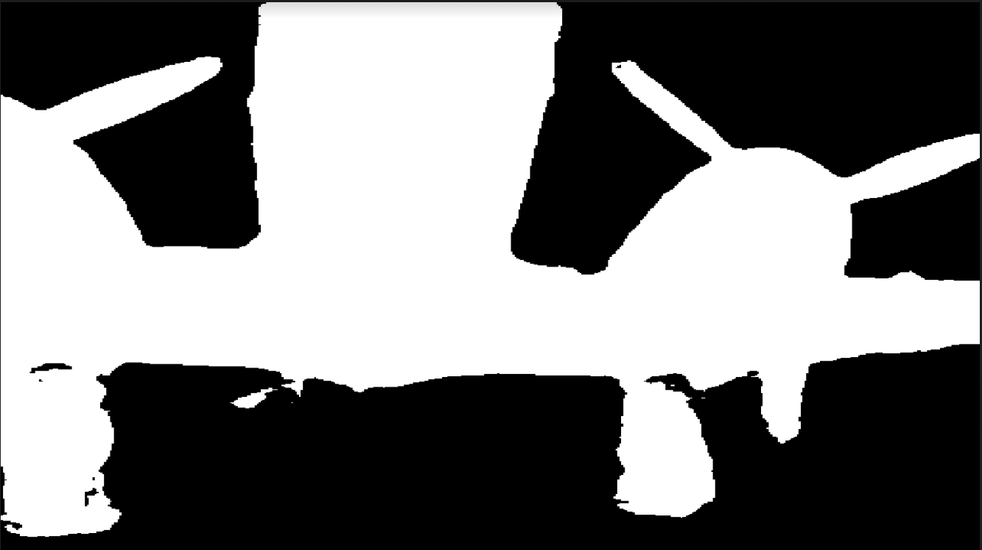

* Compared to the pretrained model, noticeable improvements saw on some ambiguous detail and edges

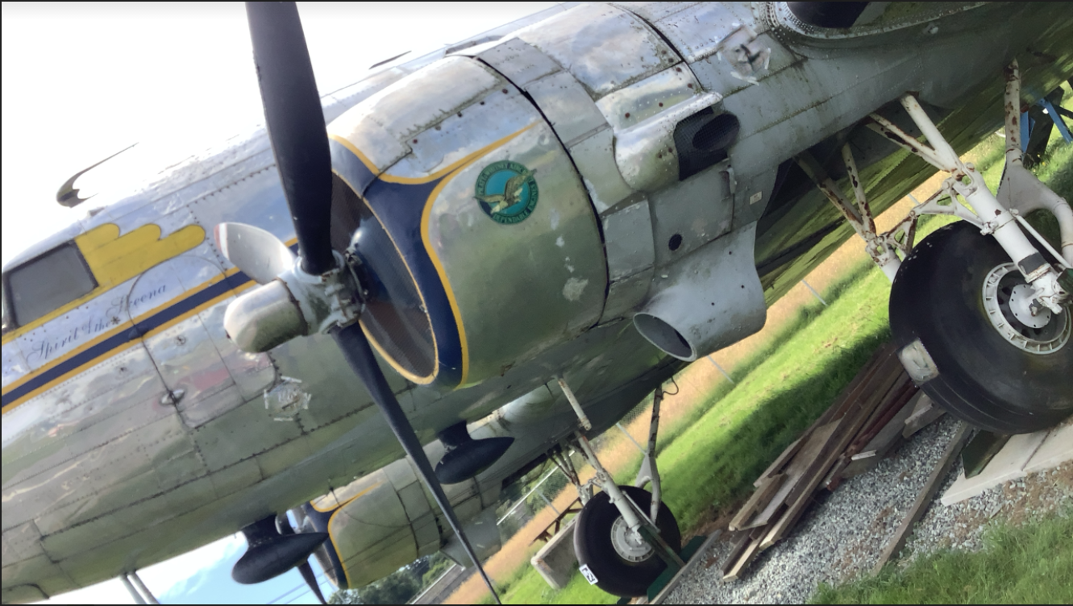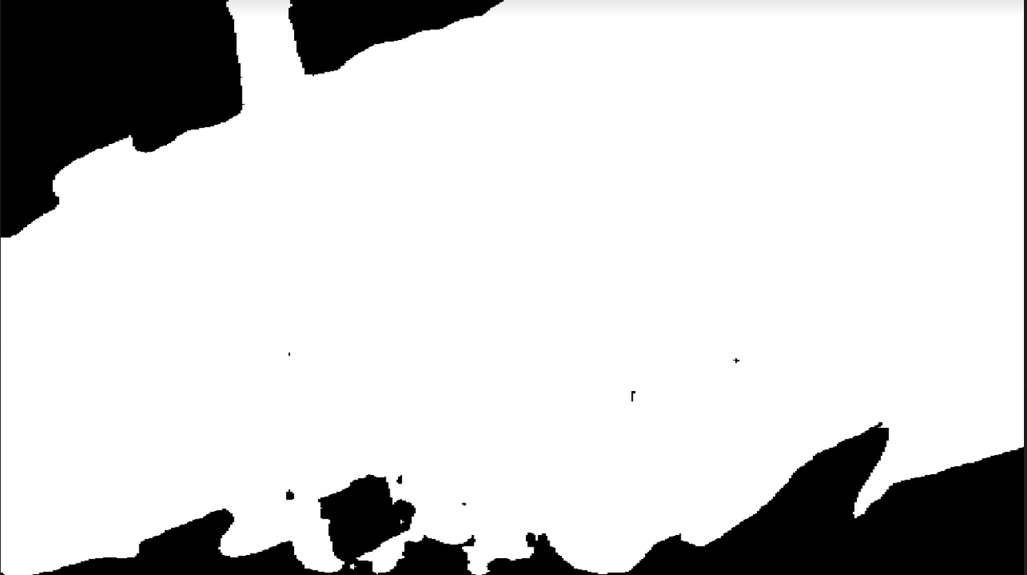 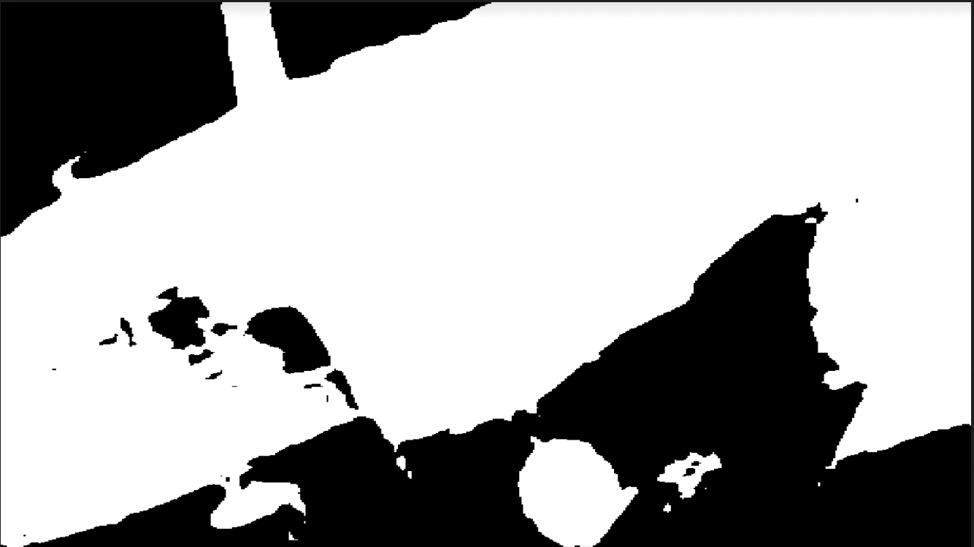

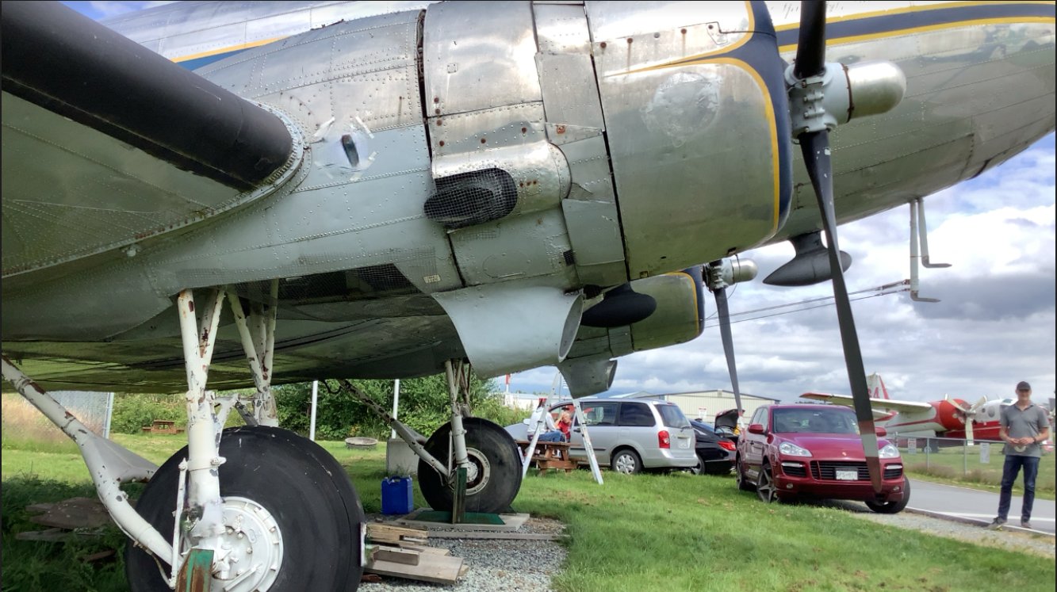 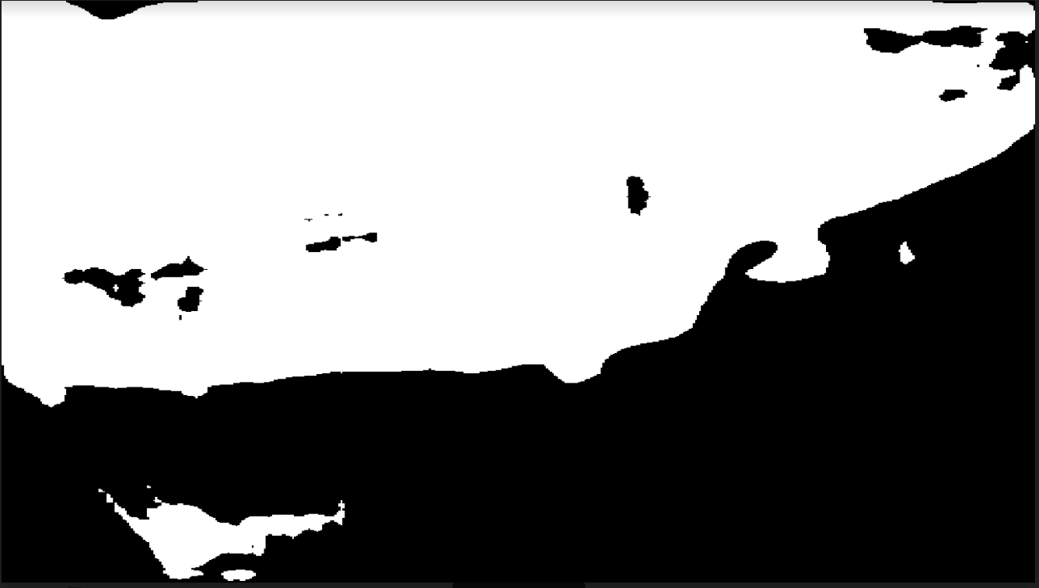 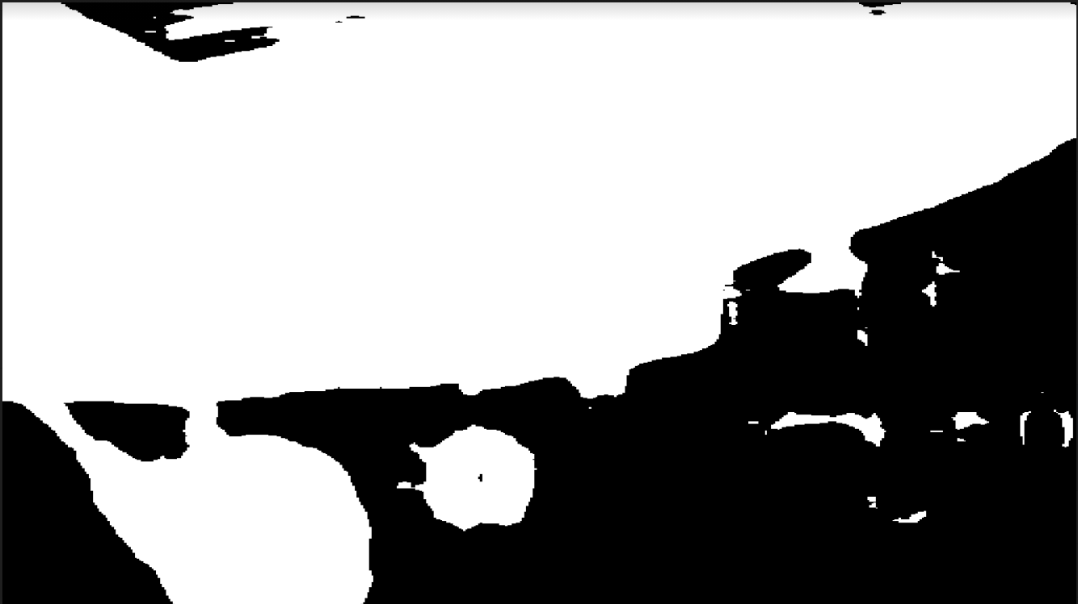

* The mostly improved segmentation are found in images where just particular part are shown, which indicates that further training it is helpful for recognizing certain components.

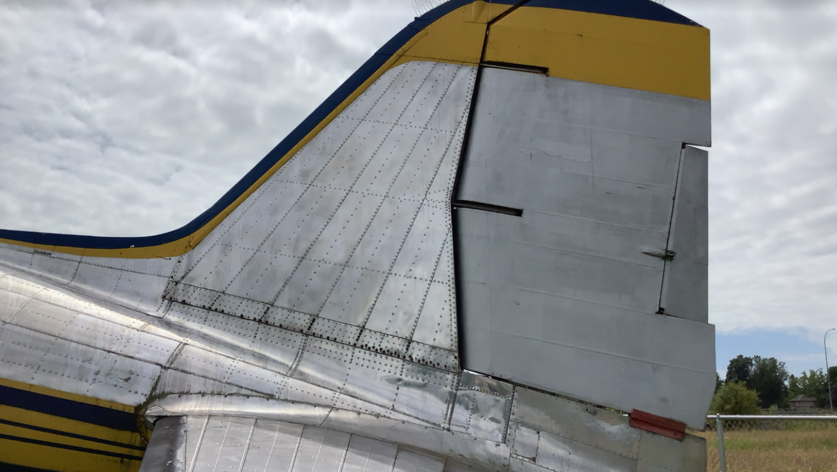  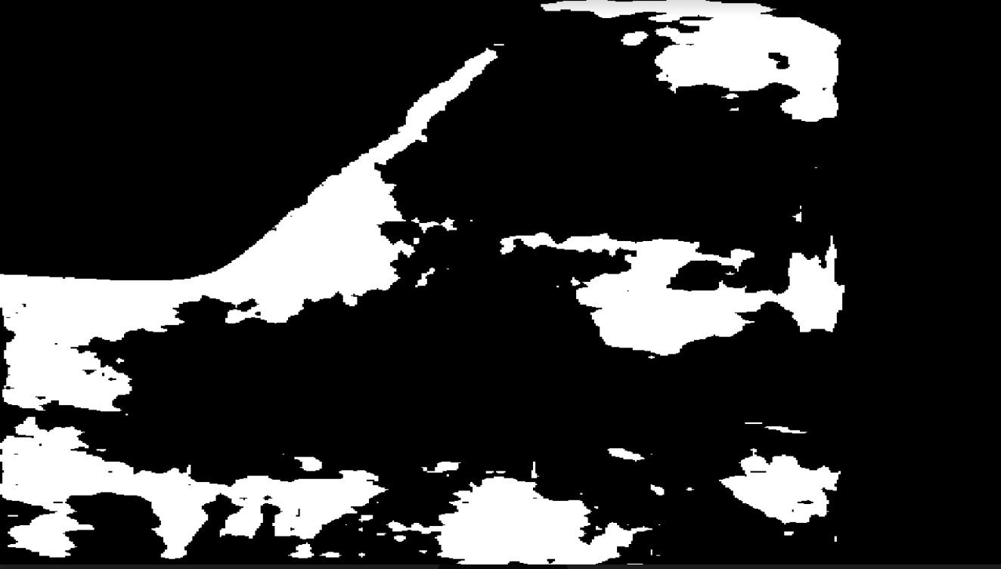

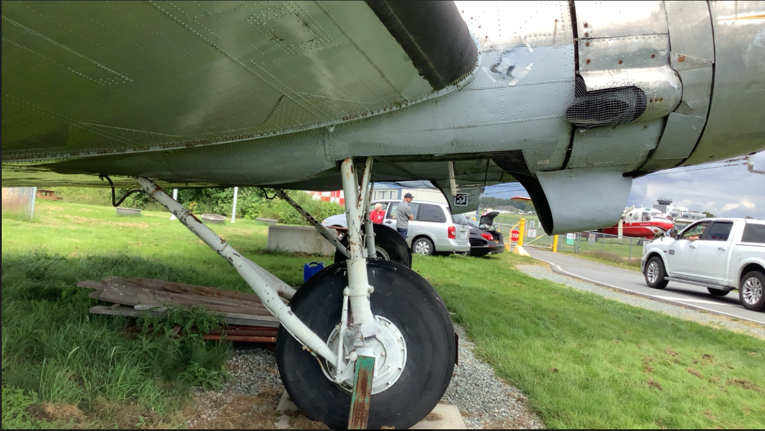 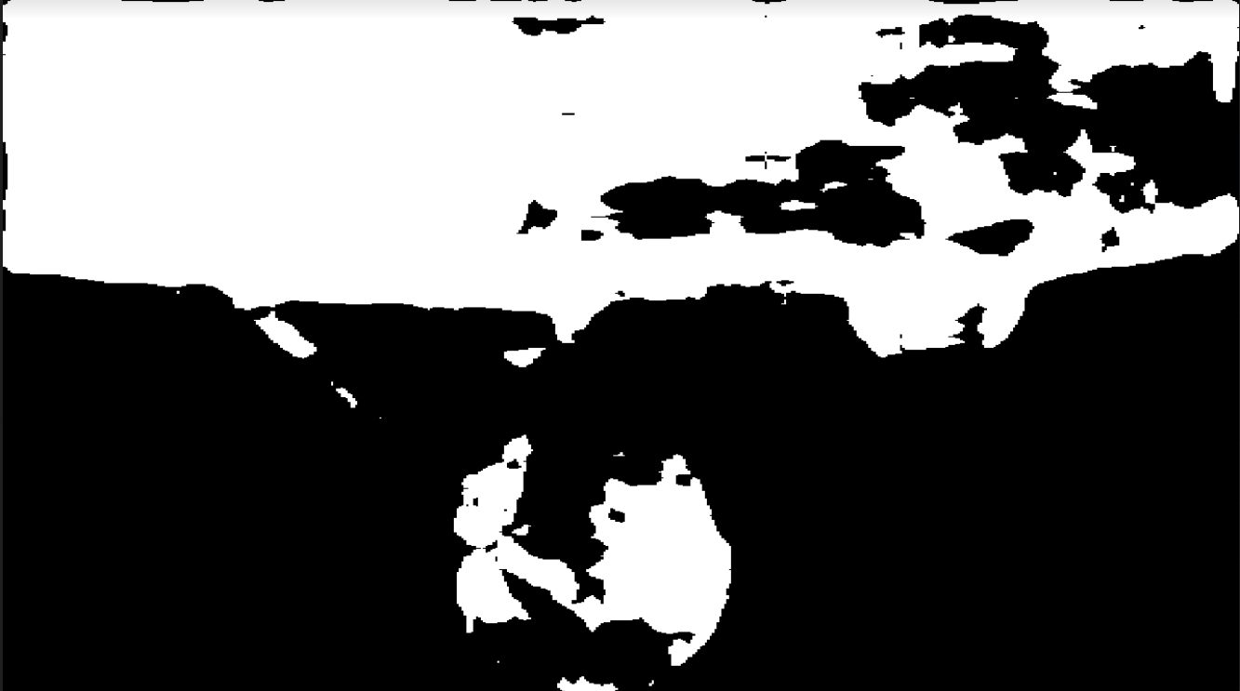 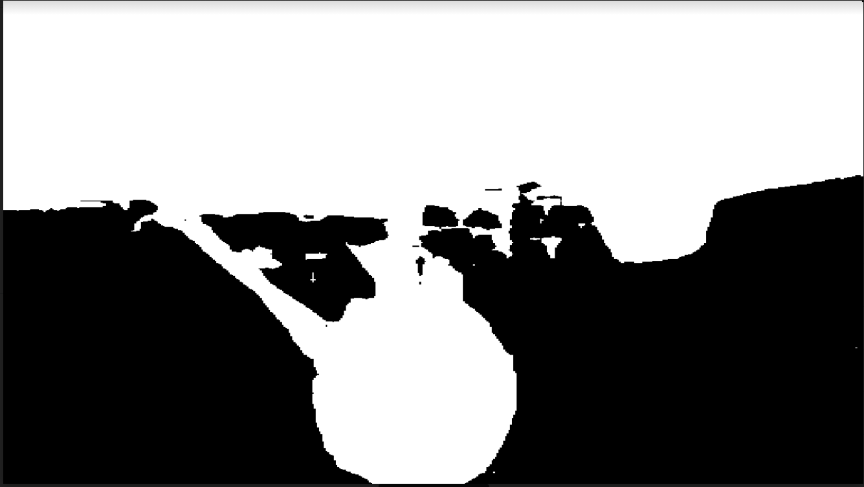

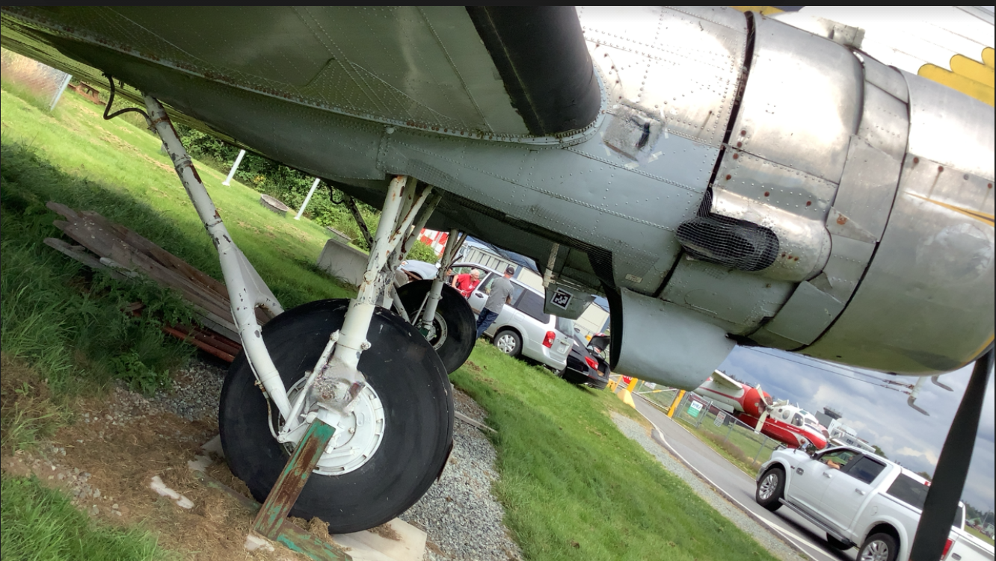 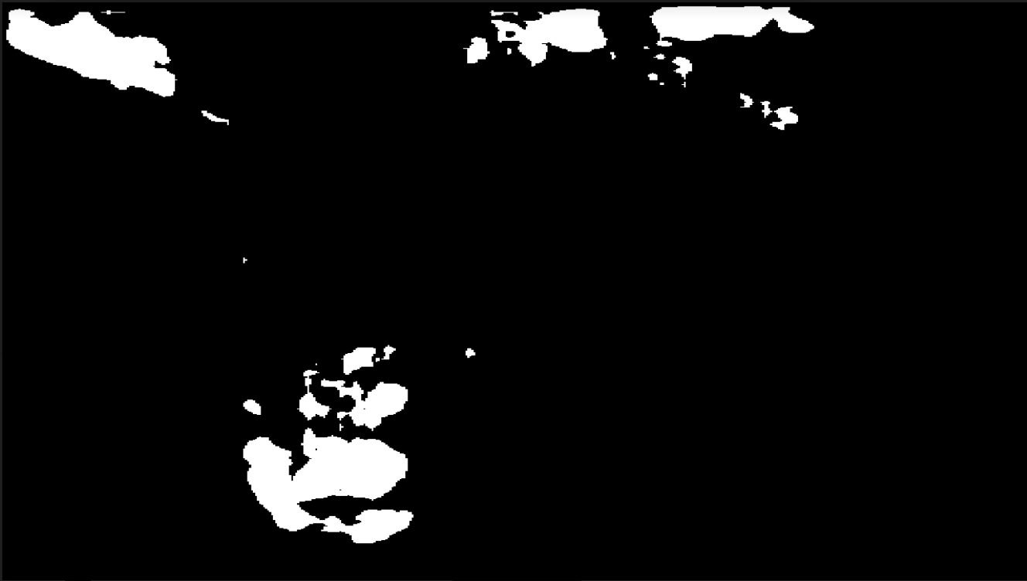 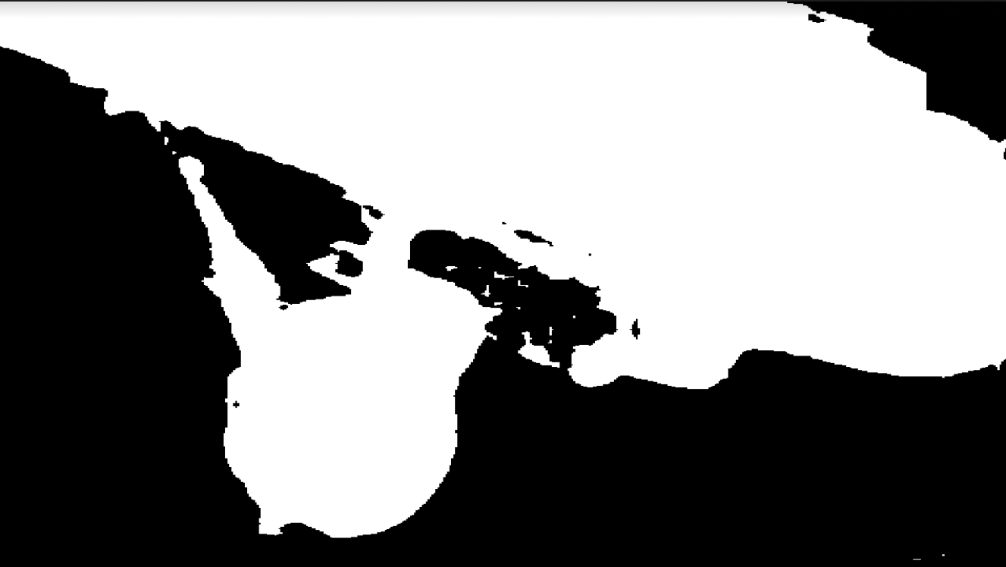

* More robust for rotated camera:

We noticed pretrain model even was not able to detect the segmentation for some cases below.

Original images pretrained model fine-tuned model

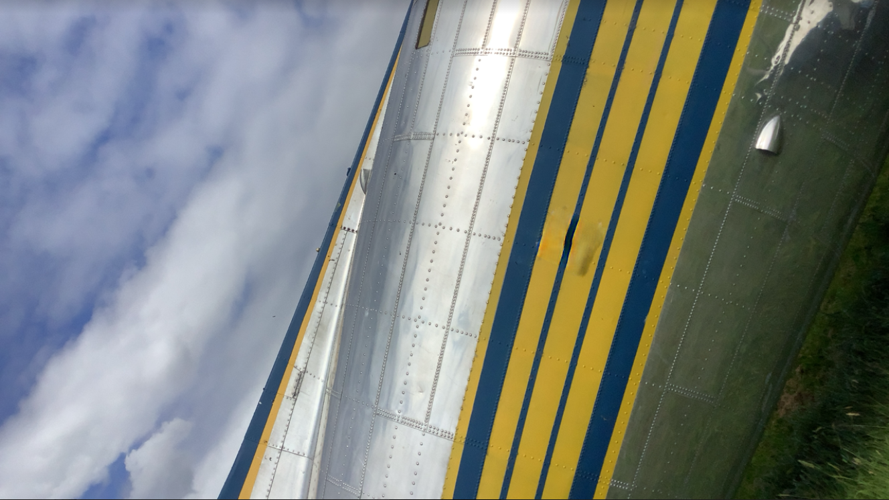  

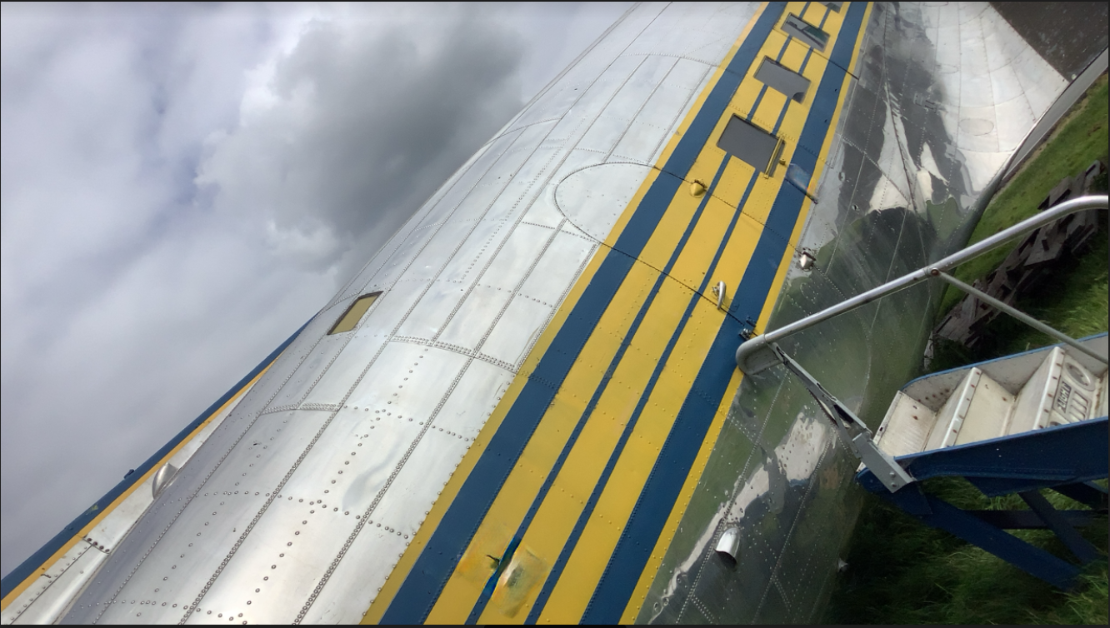  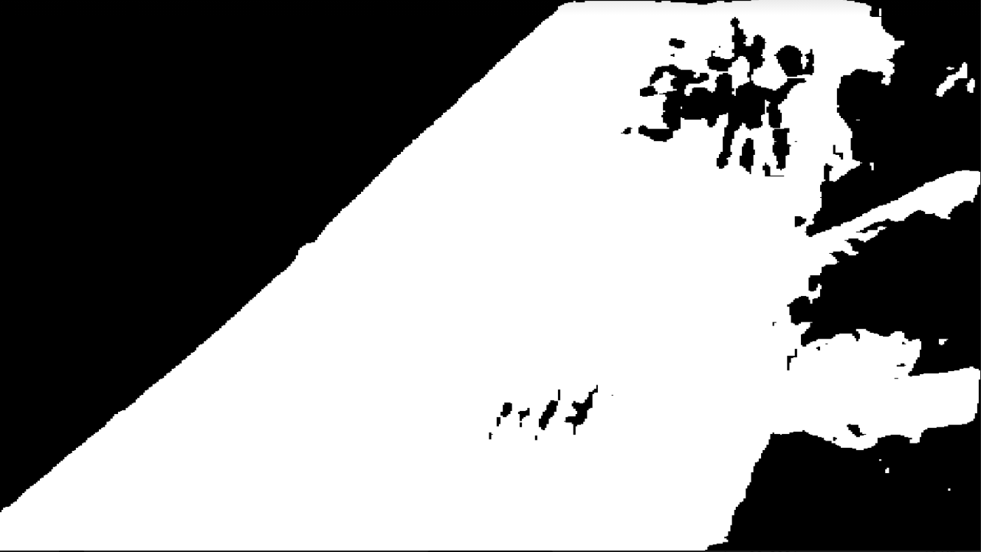

* Some flaws, mistakenly segment a little bit background.

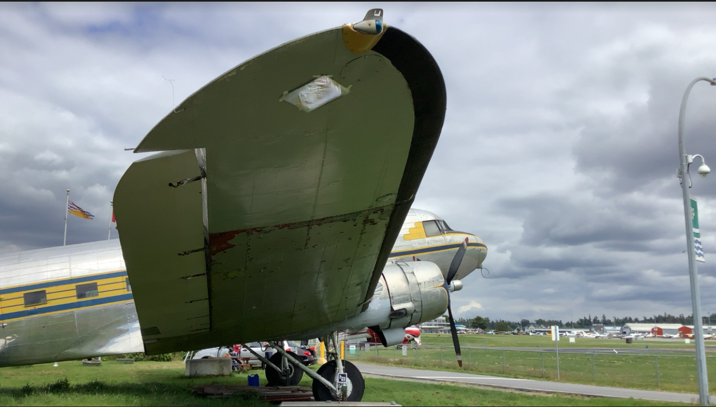 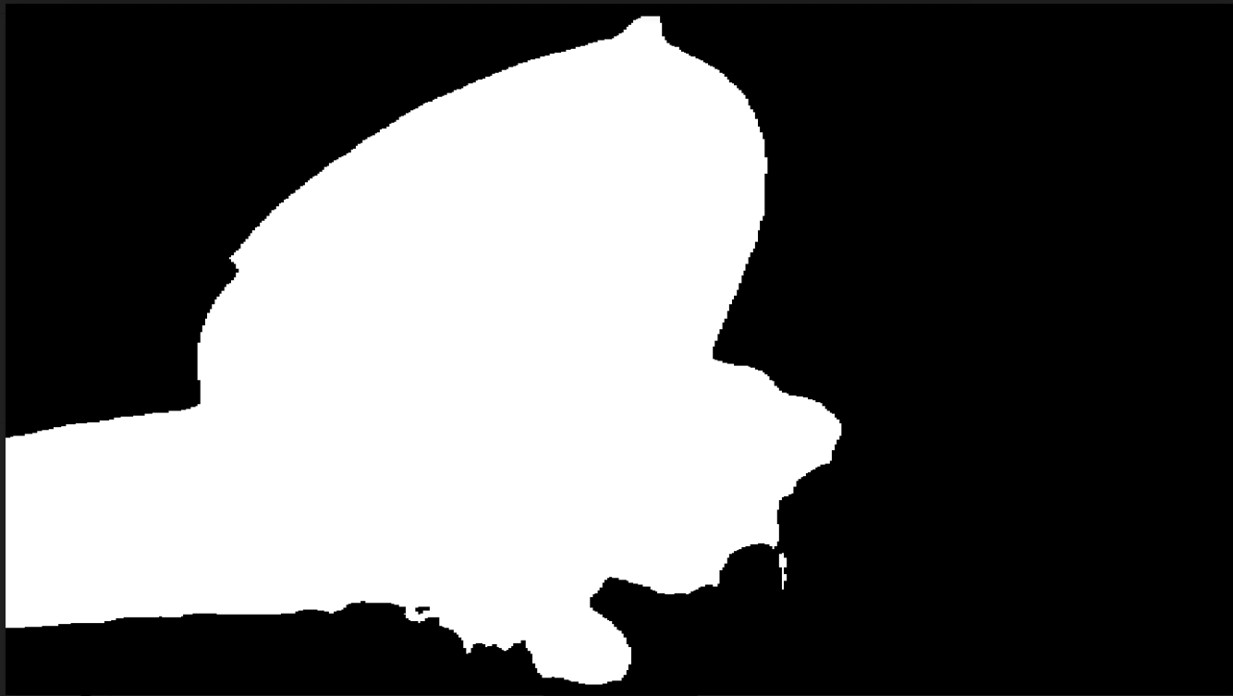 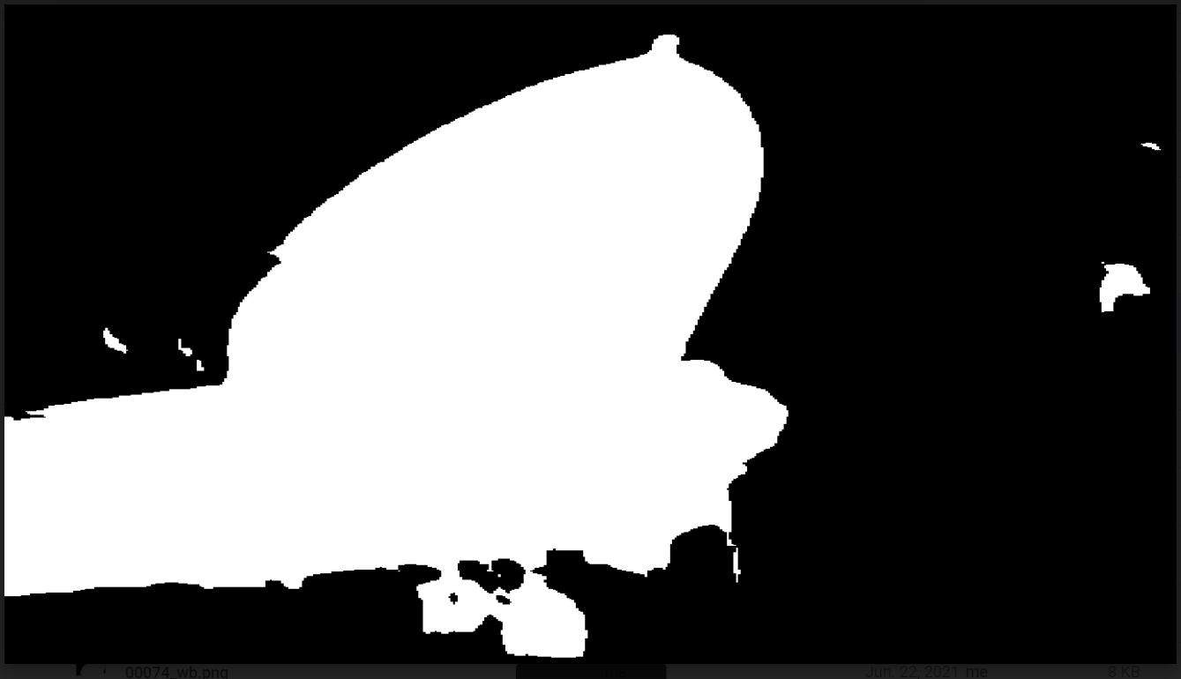

* **Phase2 Training on the entire synthetic images dataset**

Original trained on group 1 (last time) trained on group 1~ group 5

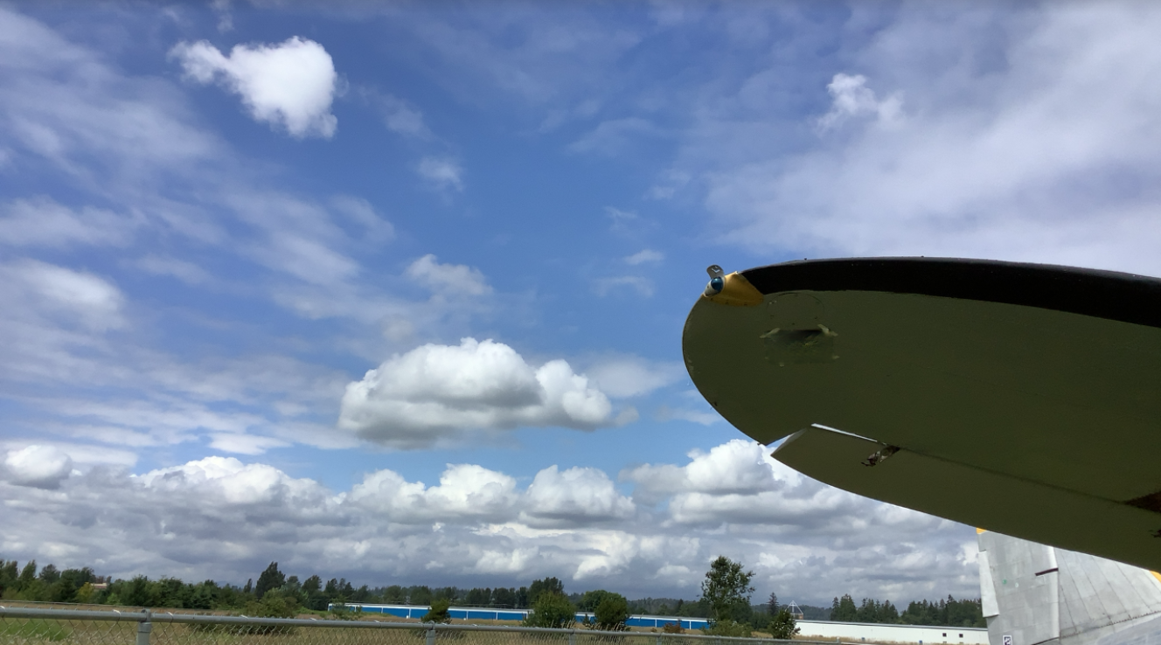 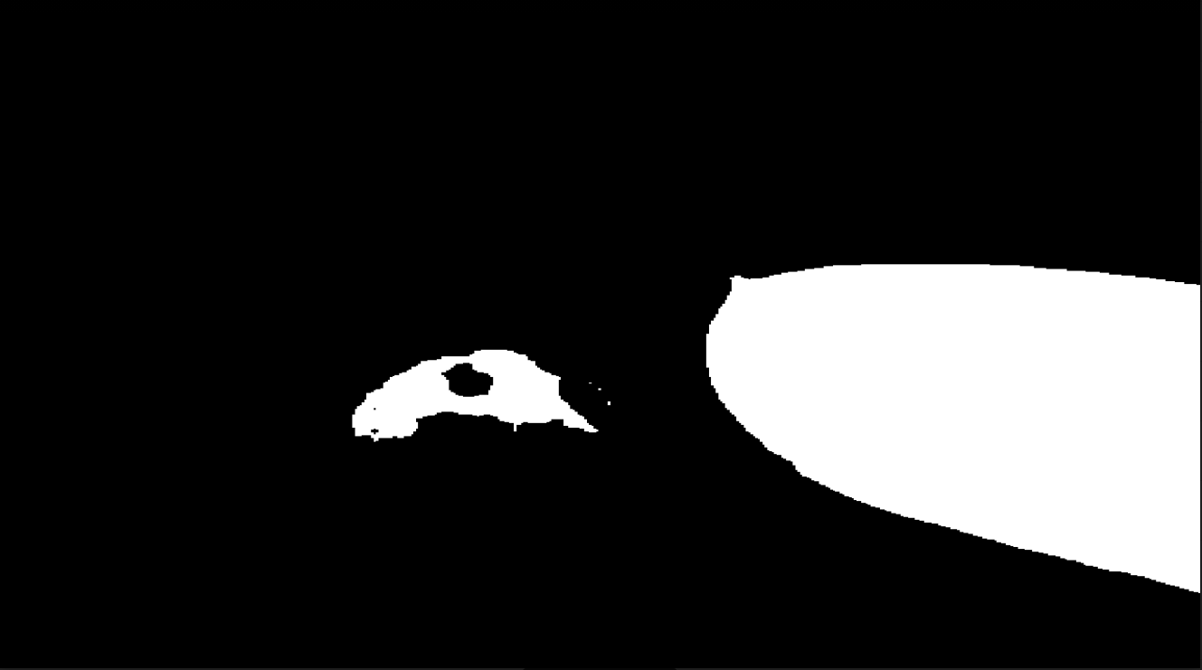 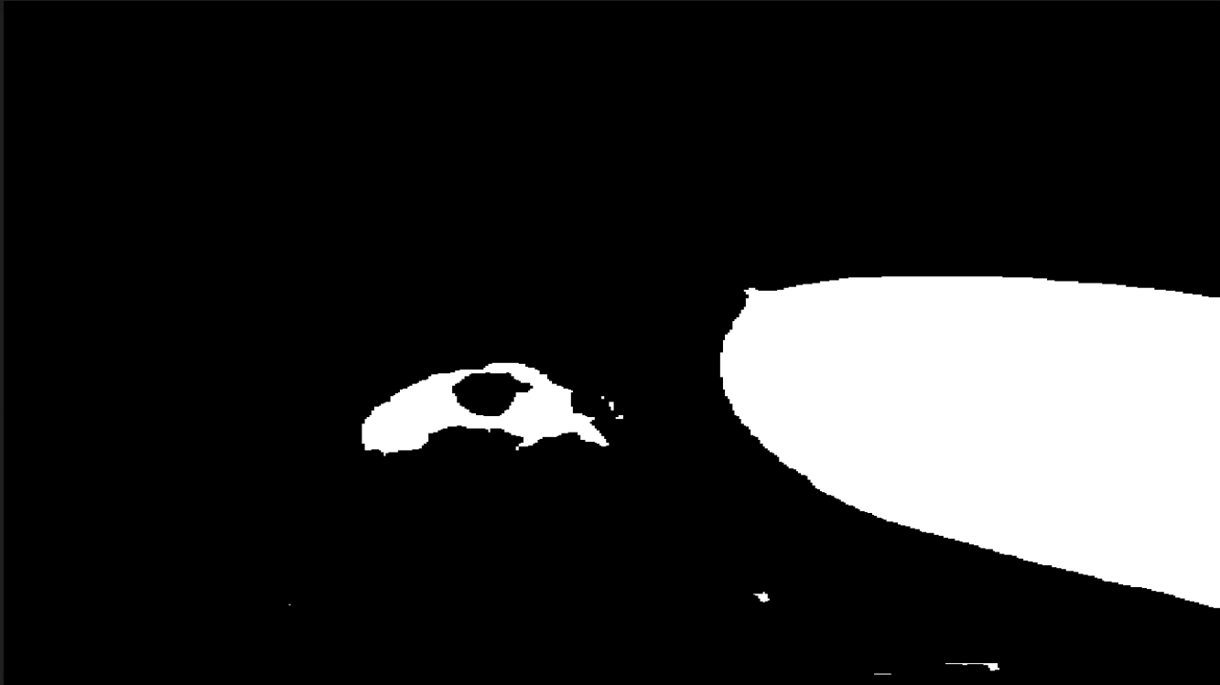

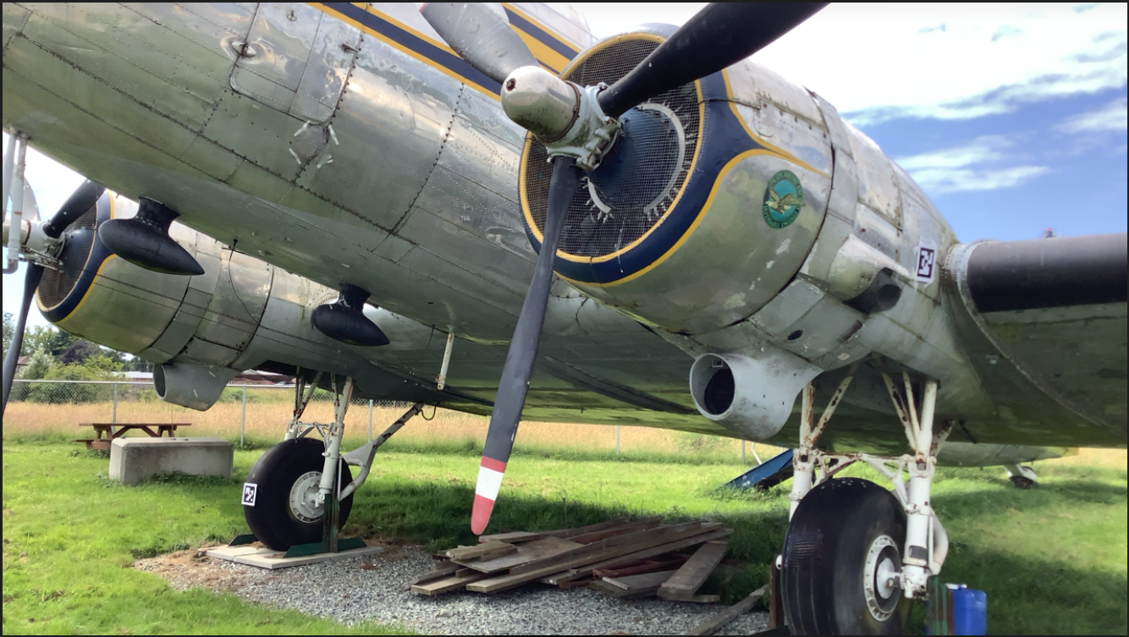 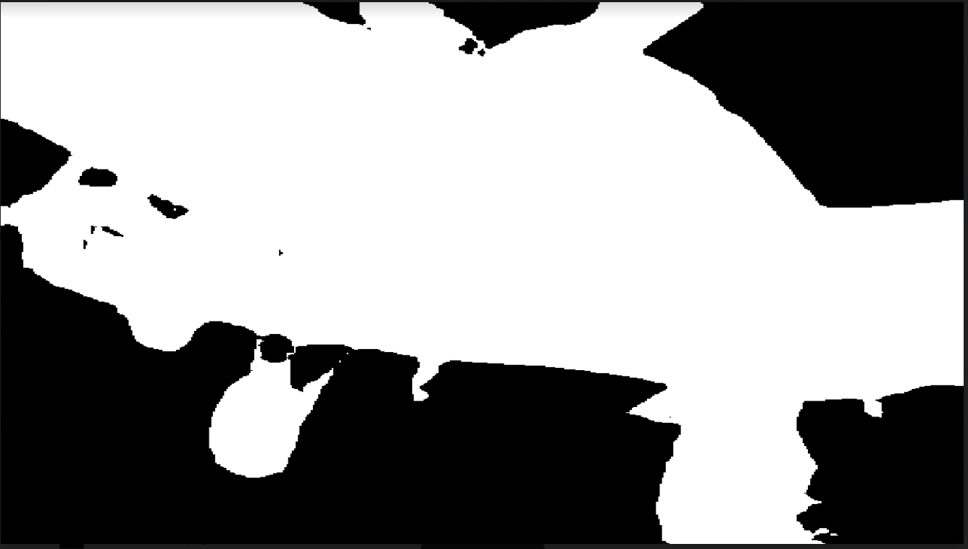 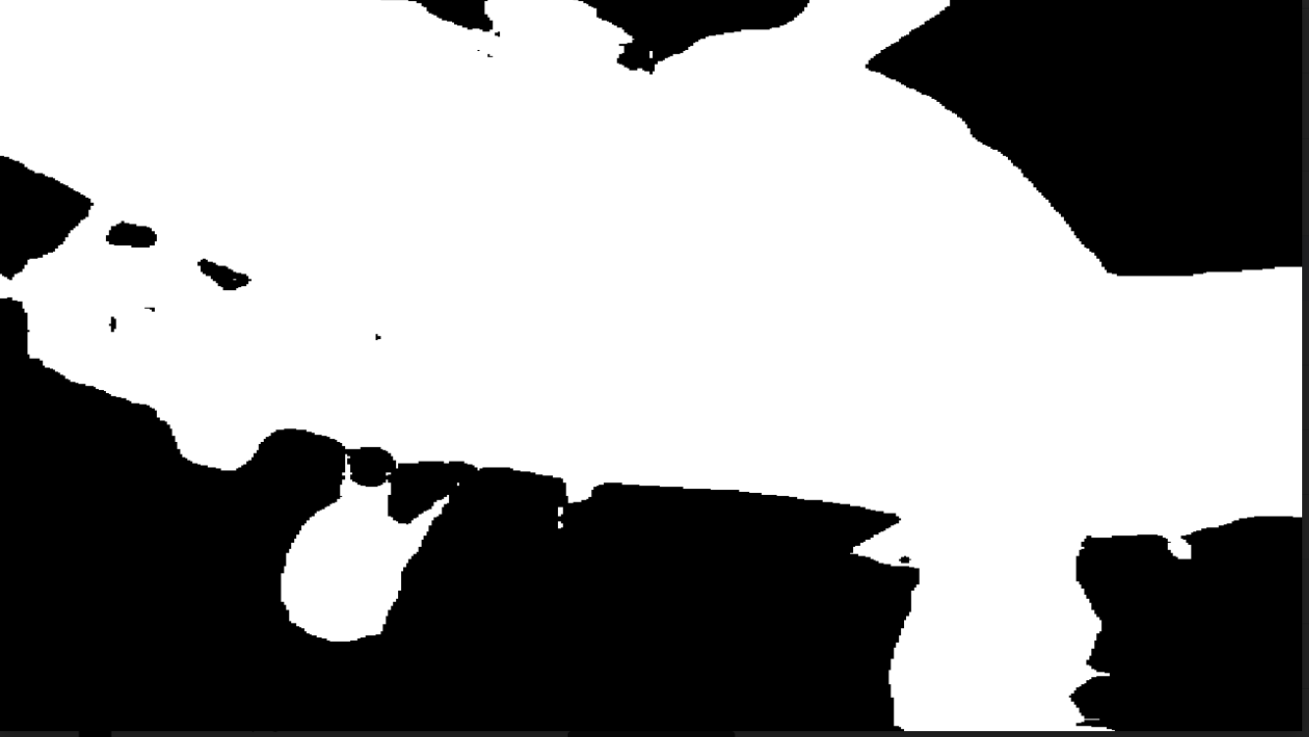

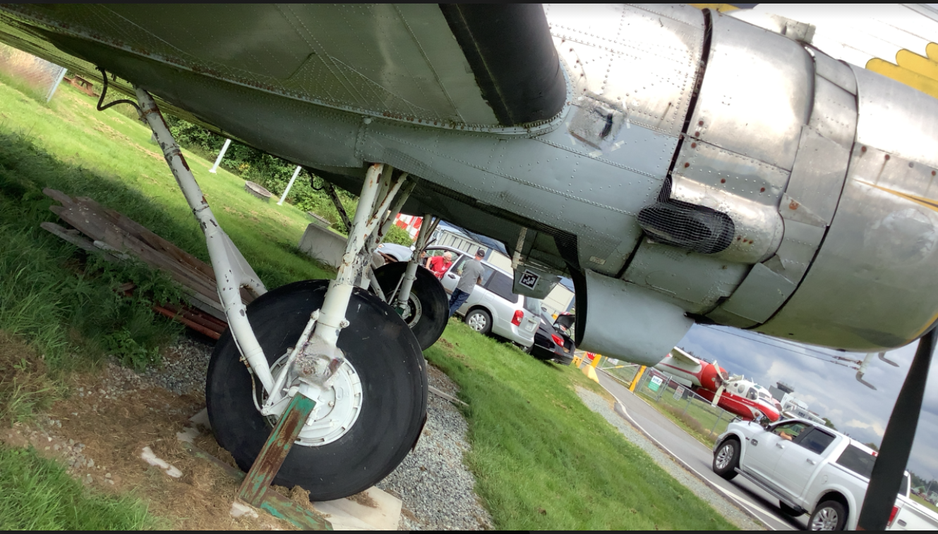 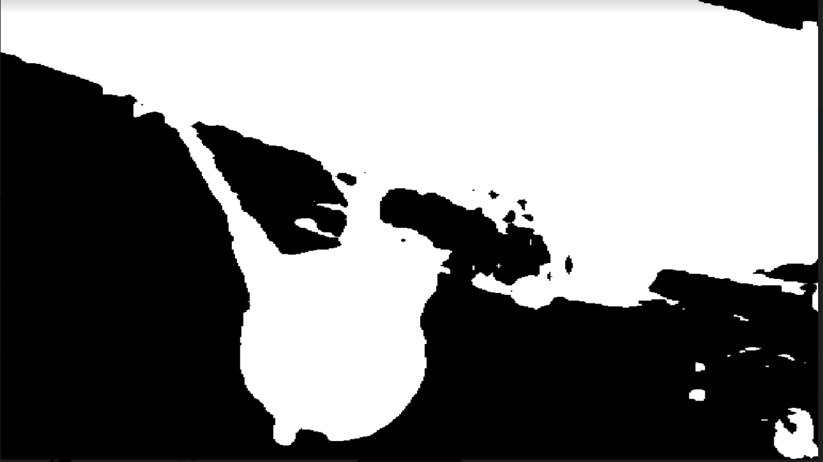 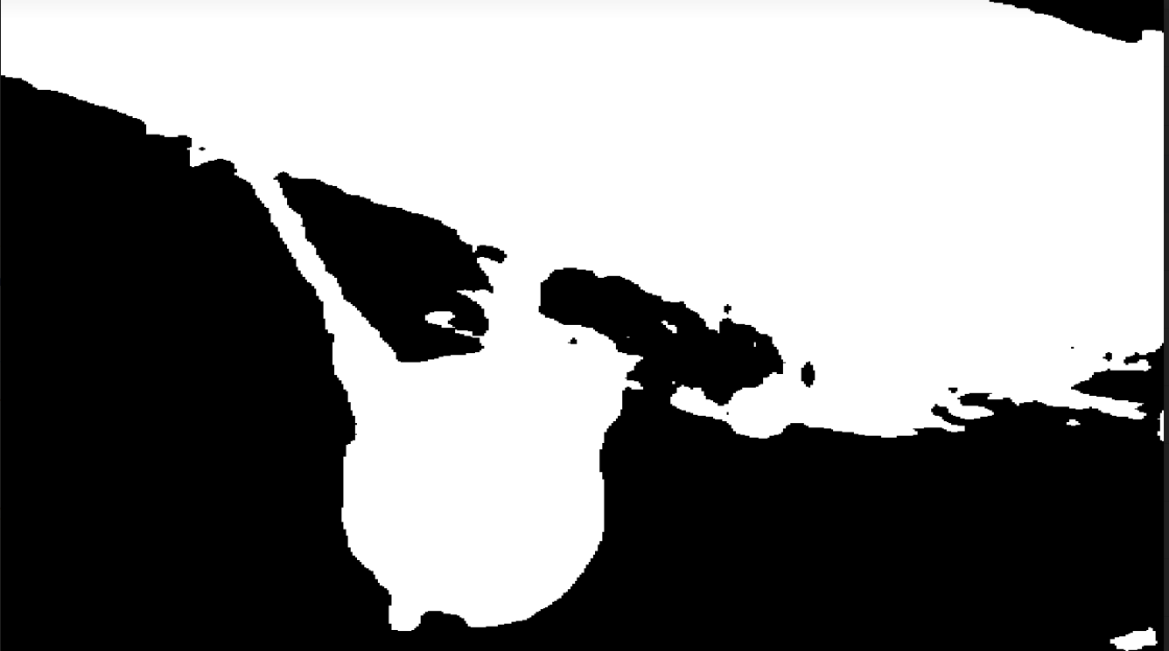

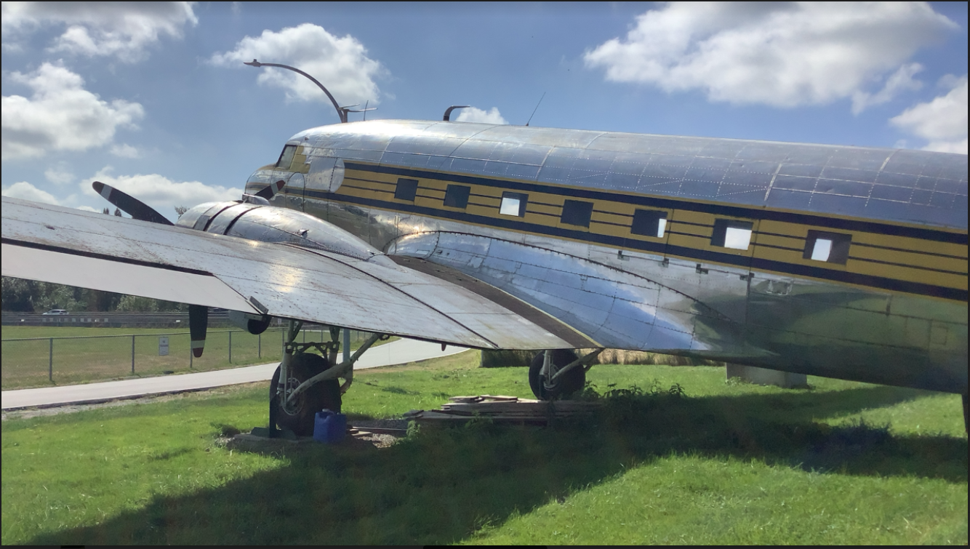 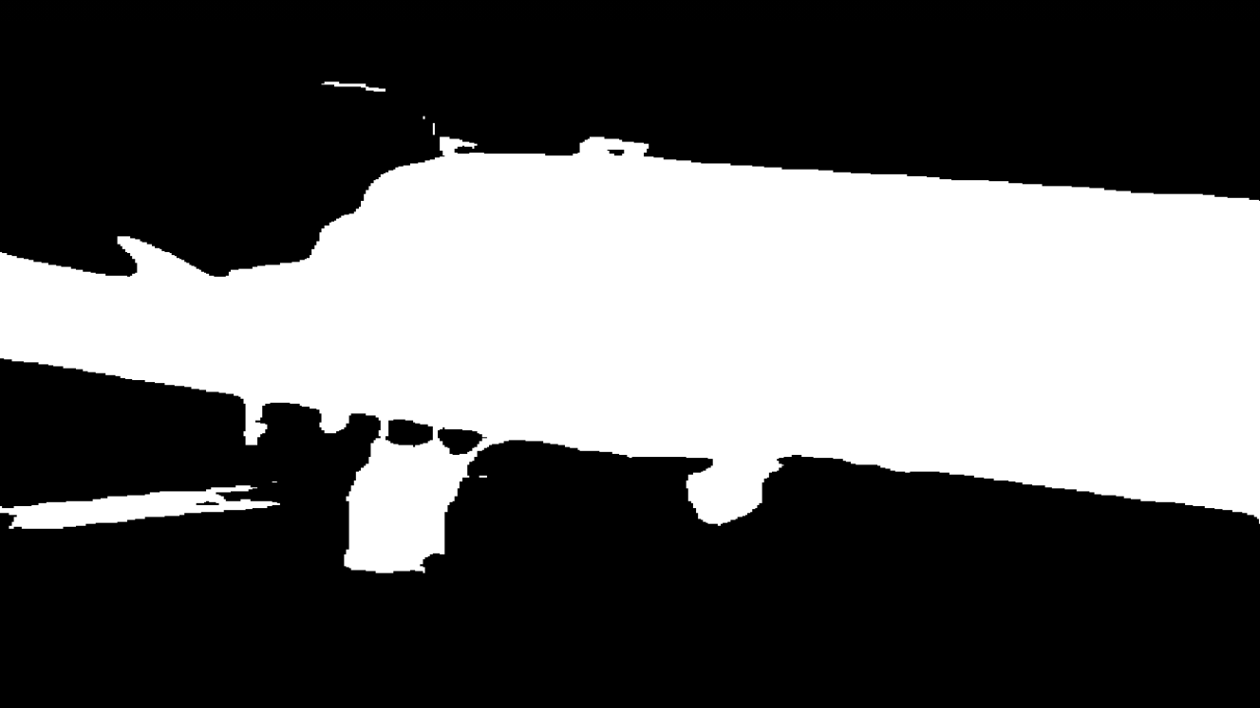 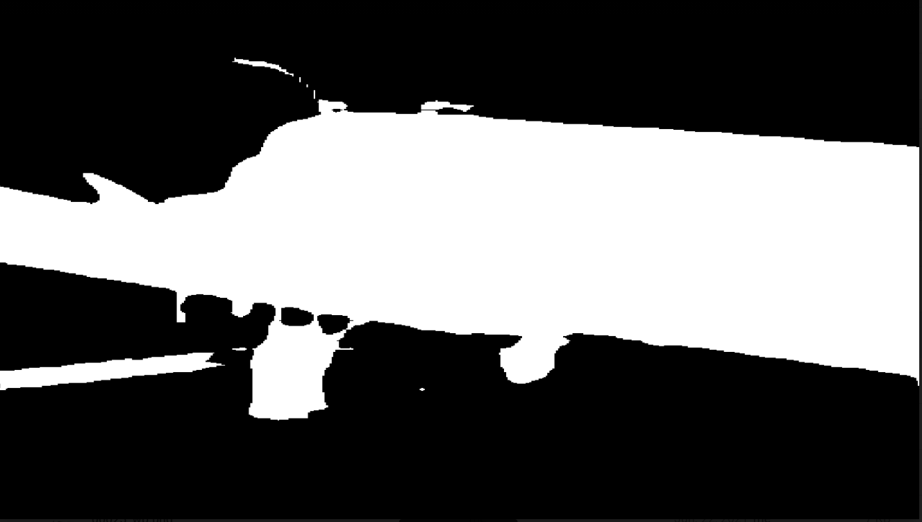

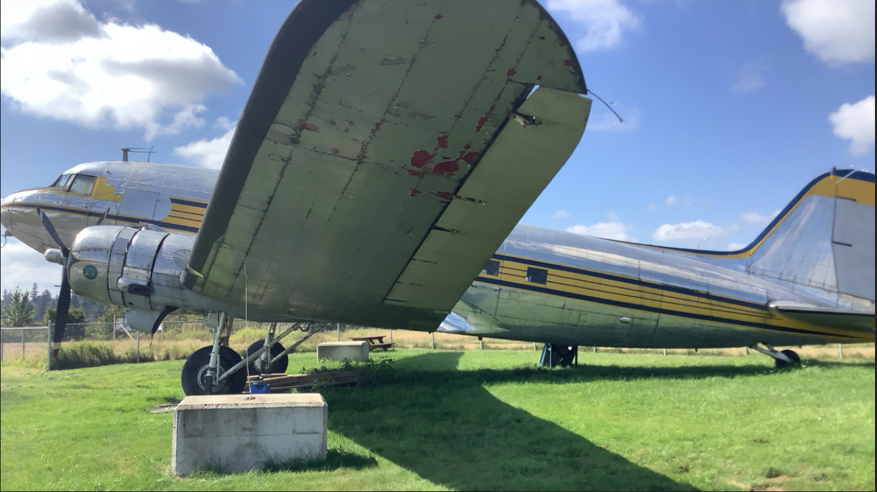 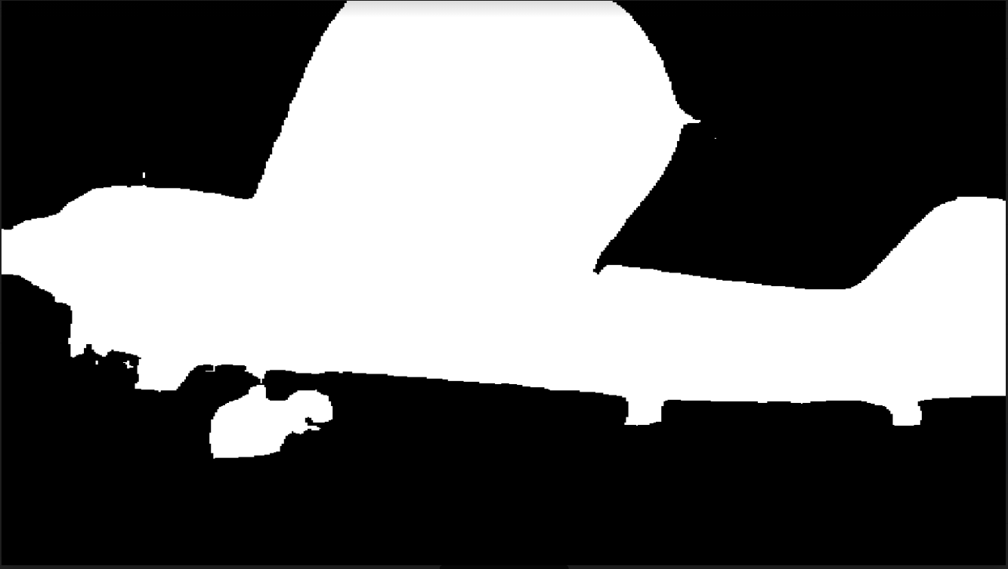 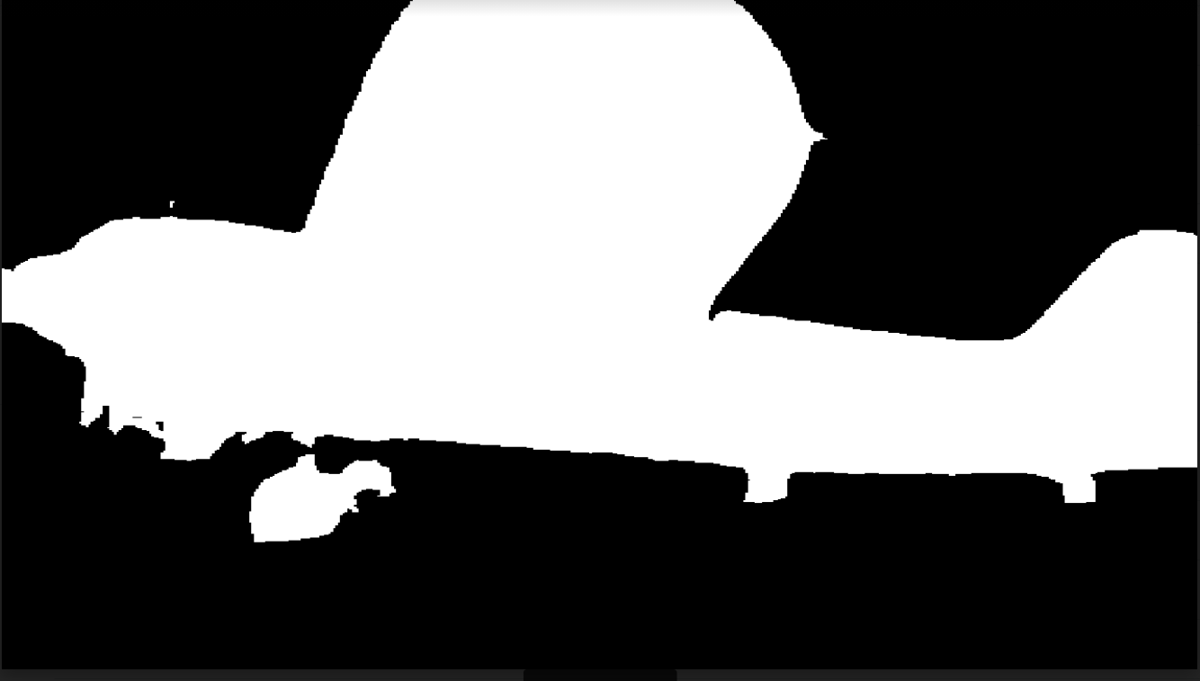

Result shows very slightly defference on the edge, but not noticeable improvement when the data become 4 times larger.

* **Conclusion.**

Further training Deeplab model did benefit segmentation for images from various perspectives or just certain component of airplane.

**Factors which impact the segmentation result:**

* Training dataset

**Suggestion for further work:**

increase training dataset from following aspect:

* Increase airplane images of different models(shapes)
* Generate more images which focus on particular component, such as certain part of airplane body, wings, the tail, engine
* More images taken from angles which cover possible viewpoint as much as possible.
* Diverse background with noises (other objects)
* Data augmentation, e.g. rotated camera.